**Final Project Protype Development**

**Stage 1.5: Design Prototype**

* Sketch and storyboard the game's key elements to visualize how the game will look and flow.
* Create two pages illustrating the color scheme, layout, and headings planned for your final project.

**Instructions**:

1. Working from your wireframes in Stage 1, update any elements that need to be changed. If no updates, then submit previous wireframes and visual sitemaps to be used in the project.
   * Wireframe of what pages will look like, at least two wireframe page styles expected
   * Visual Sitemap of how the site will be organized

Note: Page wireframes and visual sitemaps can be created as photographs of whiteboard sketches, drawn on paper, or digitally created.

Example Wireframes:

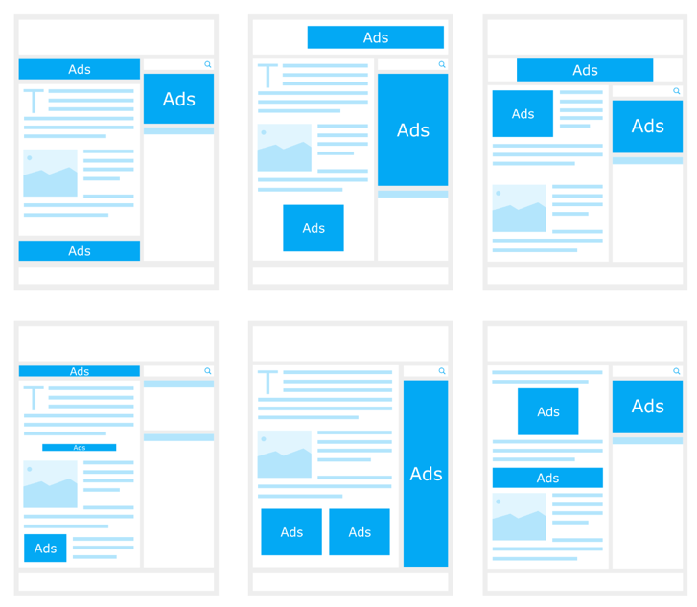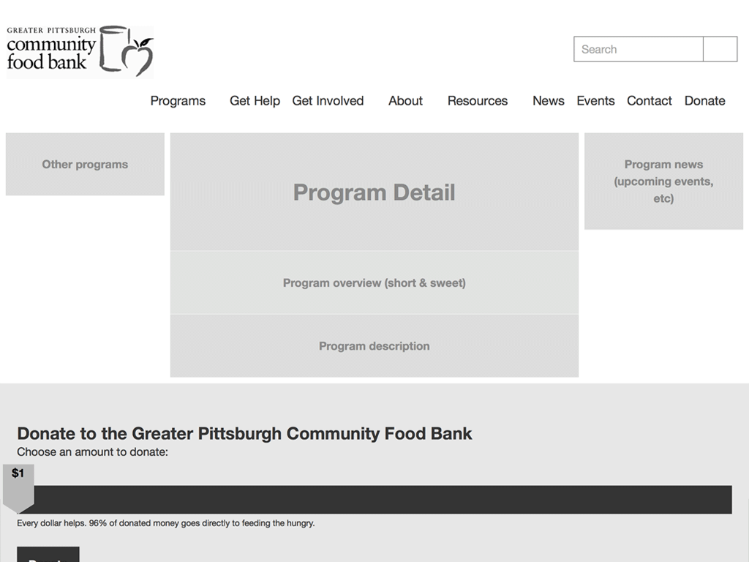

Example visual sitemap:

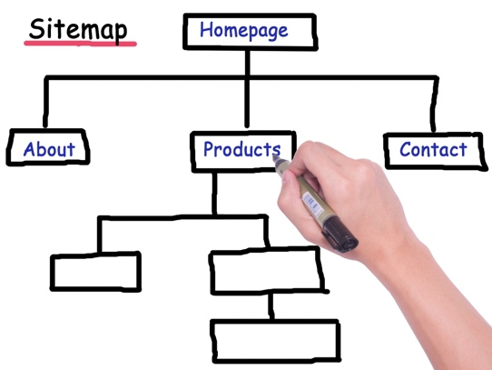 

1. Gather resources: Ensure all images used are royalty and copyright free and are optimized for web usage. You can use <https://tinypng.com/> if you need a photo editor.
   * As small as possible without sacrificing image quality on a screen, which is different from print quality.
   * Quick overview of why you’d optimize images for the web <https://mailchimp.com/resources/how-to-optimize-images-for-web/>
2. Create a prototype example of at least two pages of your final:

* Implement the HTML for required structural elements for the two pages you choose to create
* Use Lorem Ipsum text place holder to assist with rapid prototyping, fill in with content in another stage of the project
* Choose a color scheme and implement it using CSS (you’ll extend using SCSS later).
* Implement CSS for Layout and Design (floats, widths, colors, etc).
* Ensure all files are linked properly
* Fake links for additional pages may be used (href=”#”) if desired
* Seek feedback from peers or mentors to ensure clarity, originality, and alignment with the project requirements.
* Make necessary revisions to enhance the concept's clarity, originality, and effectiveness.
* Ensure that the design document is well-organized, providing clear content, visual style, accessibility, and inclusive aspects.

Organize all elements in a root folder with appropriate sub folders for images, styles, etc. Name all folders and files according to class discussed naming conventions.

Submit the compressed root folder to BrightSpace.